Exploring firewalls in Linux
- Objective
- Purpose of this lab
Learn how firewalls work and how to implement a simple firewall.
- Set up
Install 2 virtual machines
Download and install Pfsense as below instructions
Configure the network like below picture
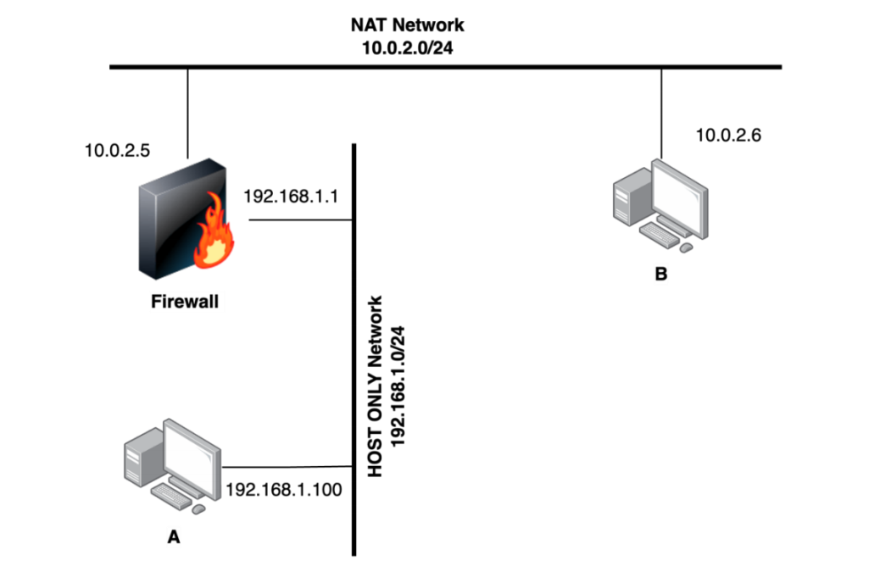
192.168.139.141
192.168.139.147
192.168.200.1
192.168.200.10
- Practice
- Install Pfsense
Download the pfsense installation file, including the CD Image (ISO) Installer, from the website
https://www.pfsense.org/download/. After downloading, extract the (.gz) file to obtain the
.iso file and install the virtual machine.
In this lab I use Pfsense version 2.5.0
- Configure Pfsense
Step 1: Create new virtual machine with the .iso file
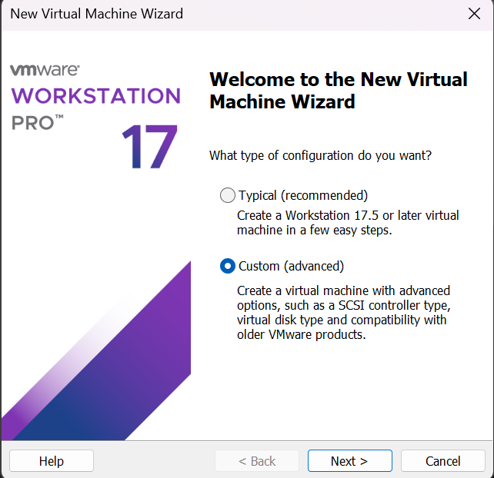
Step 2: Remember to add one more network adapter, because Pfsense use one for WAN and one for LAN
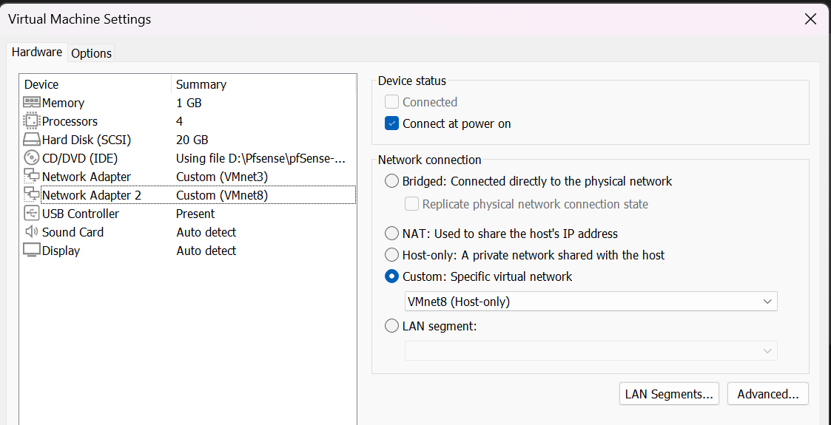
Step 3: Select install Pfsense
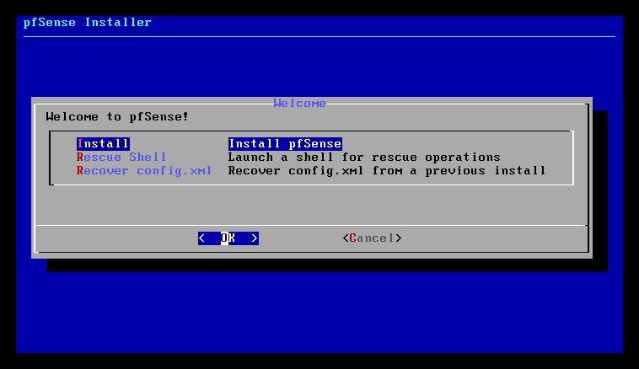
Step 4: Choose option 2 then change the LAN IP to another IP, whatever you like, then turn on DHCP for it, and turn off the DHCP from the network adapter
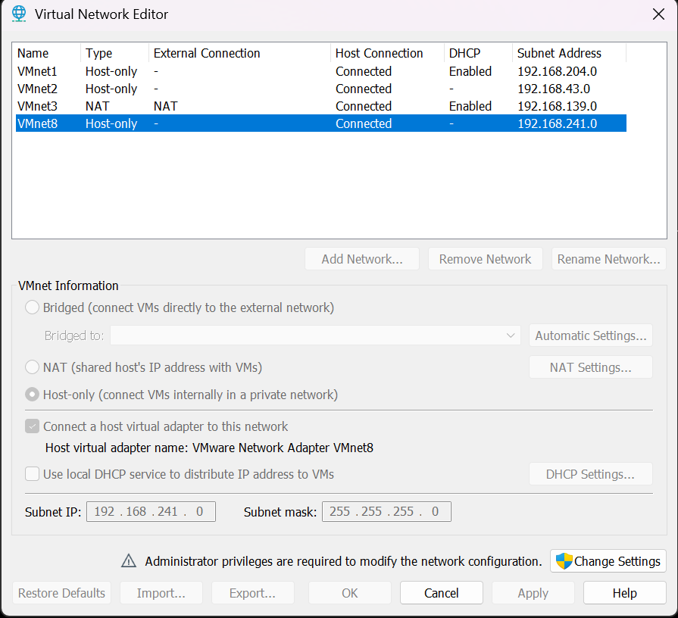
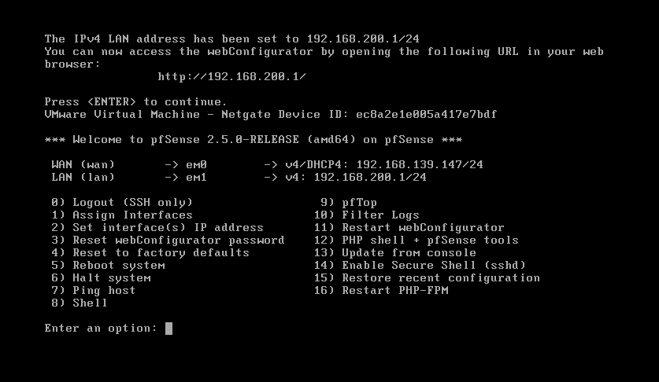
Now pfsense will also be a dhcp server, when any machine use VM net 8, pfsense will assign IP for it.
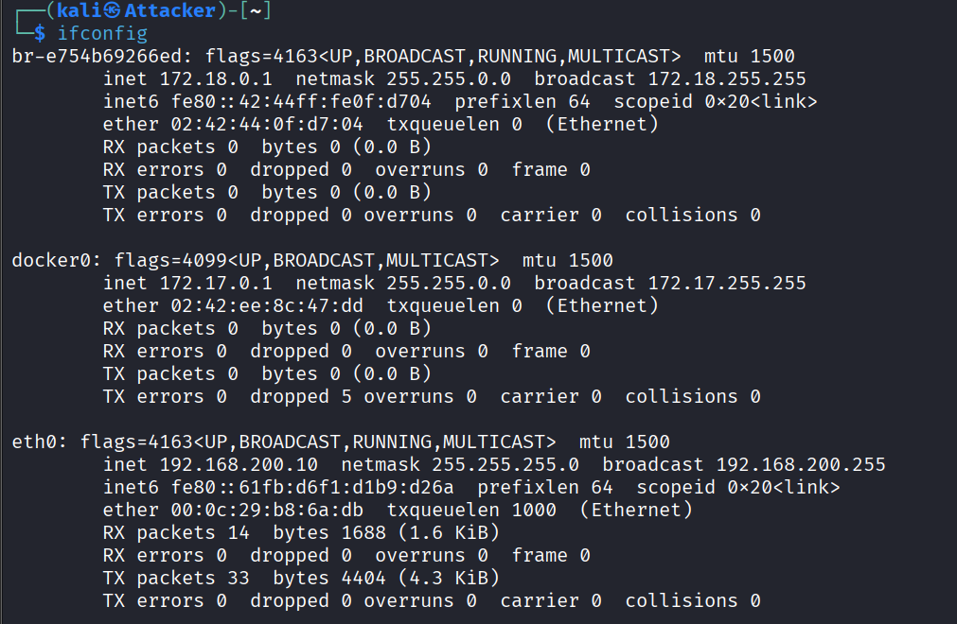
After successful installation, use another machine to access pfsense via the address http://192.168.200.1 with the default username and password admin/pfsense.
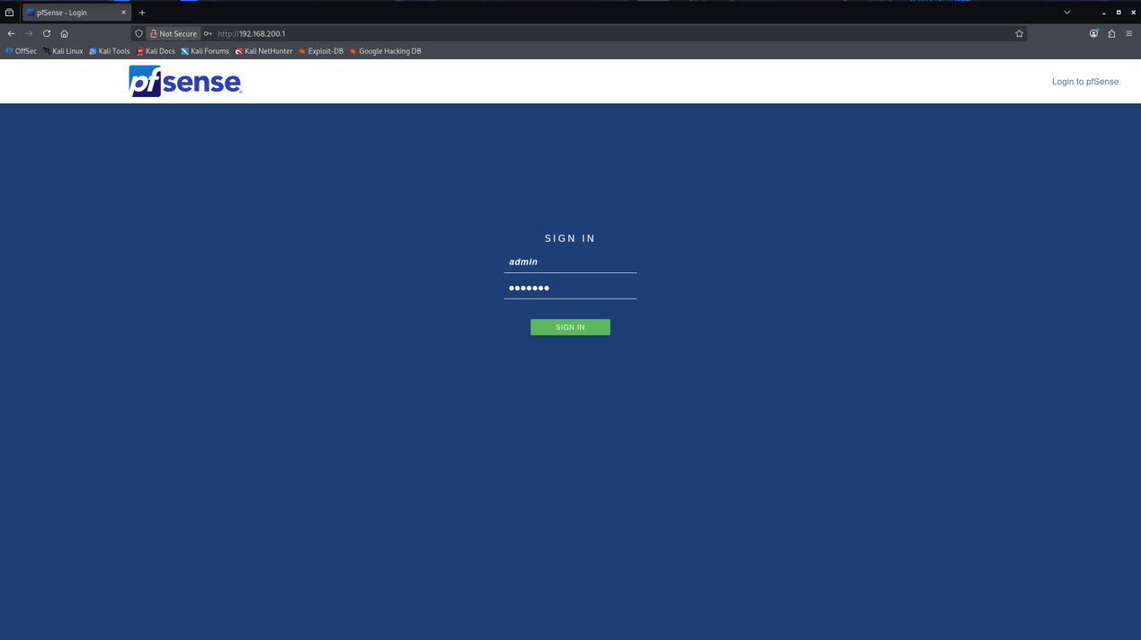
After installation, pfSense operates as a router and firewall. Hosts connected to the LAN (host-only network) receive IP addresses via pfSense’s DHCP service and use pfSense as their default gateway. Outbound traffic is translated using NAT on the WAN interface, allowing LAN hosts to access external networks while preventing unsolicited inbound connections.
- Set up policies on the Firewall to protect the internal network
You can configure pfSense rules by going to Firewall → Rules → Add. In which:
- Action: Select Pass / Block / Reject corresponding to the action you want to perform.
- Protocol: Protocols applicable to this rule
- Source, destination: Packet information to filter (network layer, host address,
source port, destination port,...)
Pfsense dashboard
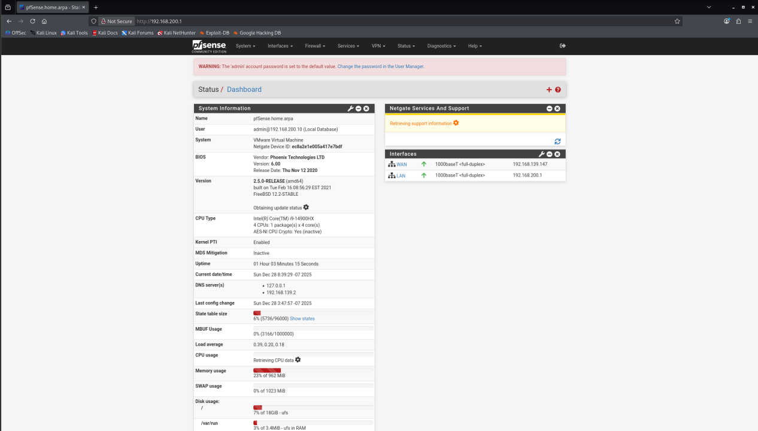
Now go to Firewall -> Rules -> Add
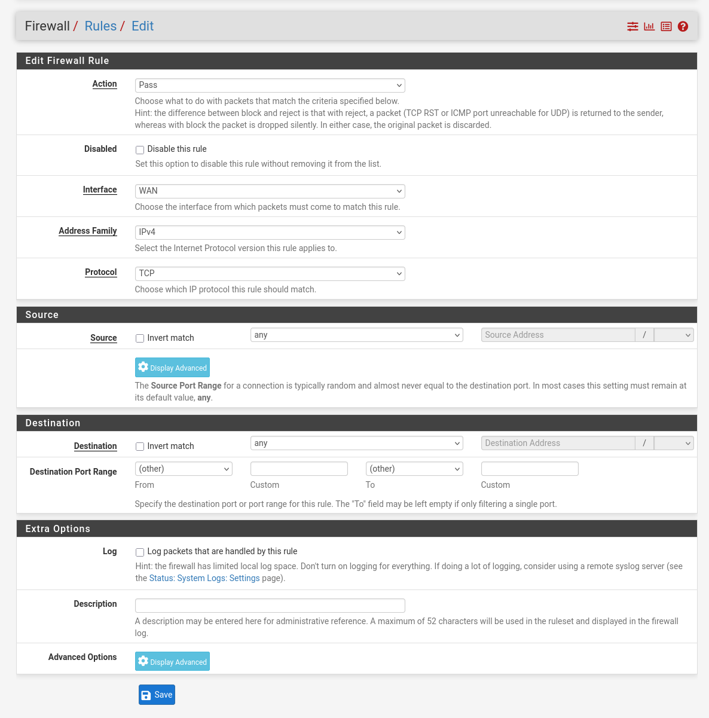

Task: Understand and implement the following rules (in order):
- Do not allow machines on the internal network (192.168.200.0/24) to ping VM B (192.168.139.141).
- Do not allow machines on the internal network to access websites using the HTTP protocol (port 80).
- Block telnet connections from the internal network to the outside.
- Do not allow machines on the internal network to access www.facebook.com and youtube.com.
After implementing the above rules, use VM on host-only to test.

Move to the first task, let’s quick test the ping first before implementing new rule.
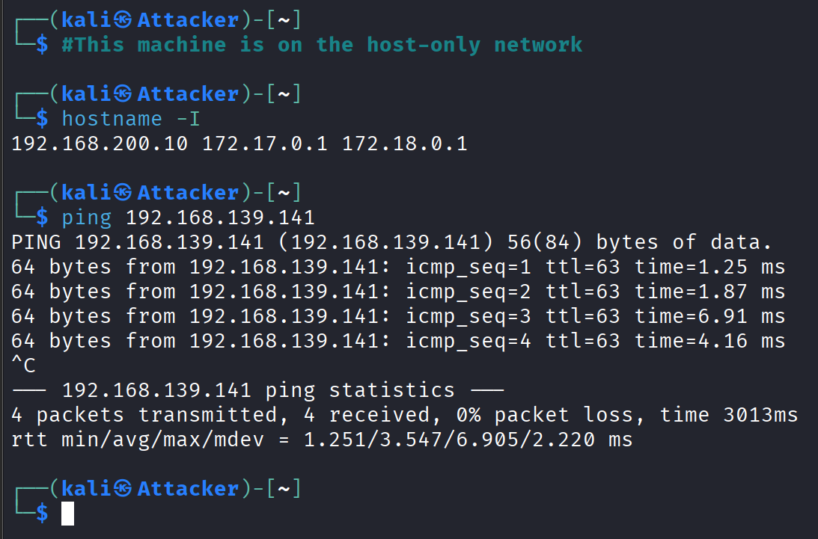

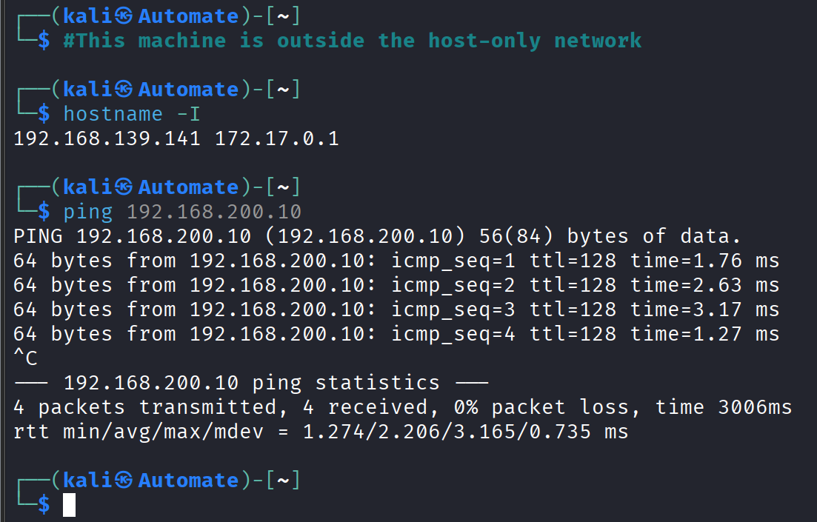
So we can confirm that both machine can ping each other. Let’s implement a new rule to not allow the VM on host-only network ping the VM outside.
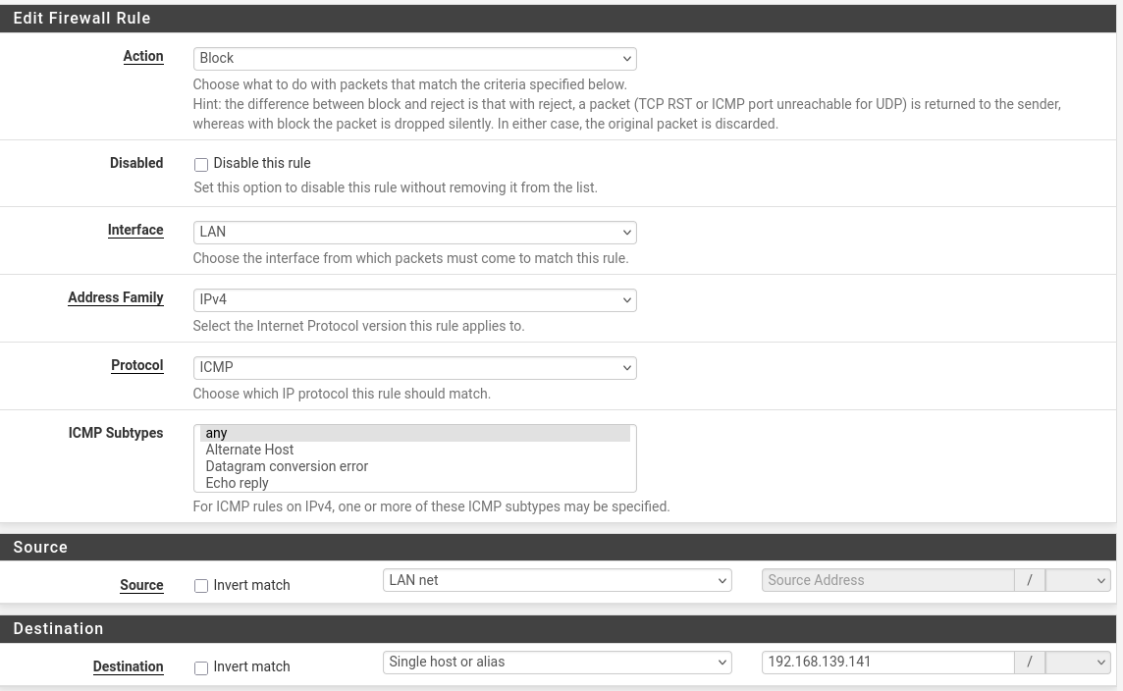
Then, click “Save” and the rule will be enabled on LAN.
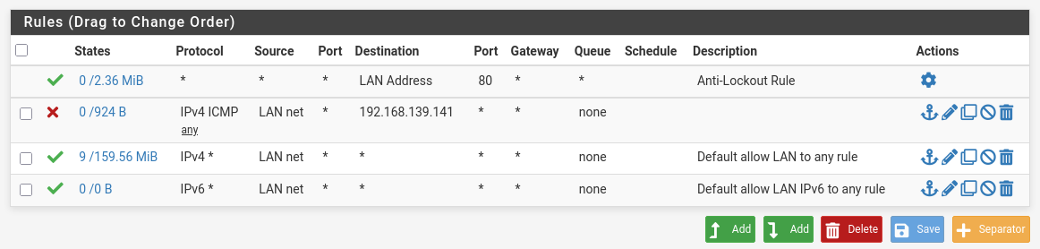
Now, VM on the host-only network cannot ping to the VM B.
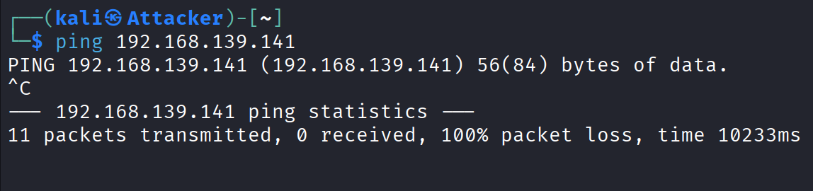
The packets in wireshark show that there is only “no response found” , not any reply.
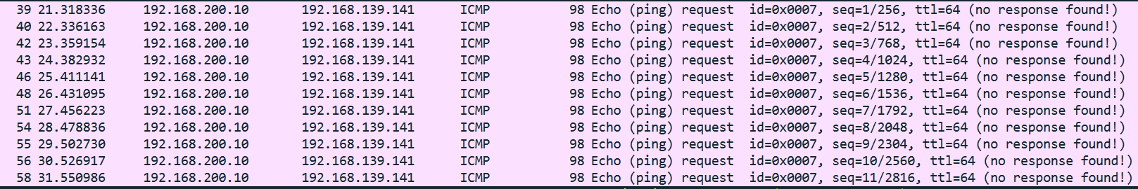

But VM B still can ping to the VM on host-only network.
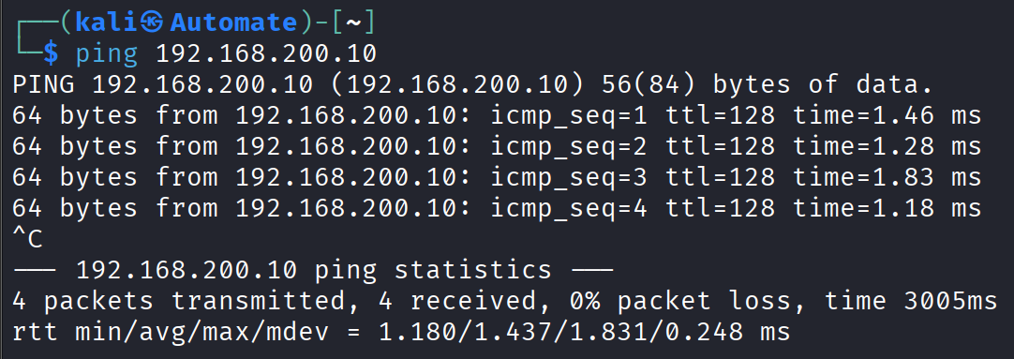
In wireshark, we can also see it more clearly.
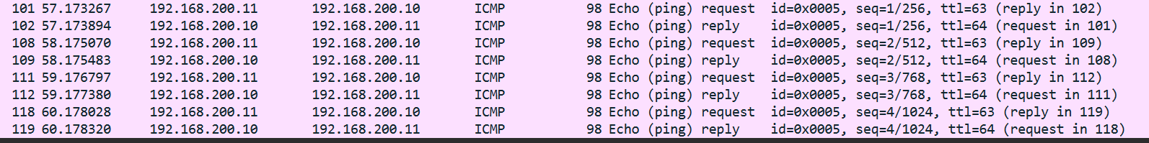
WAN rules.
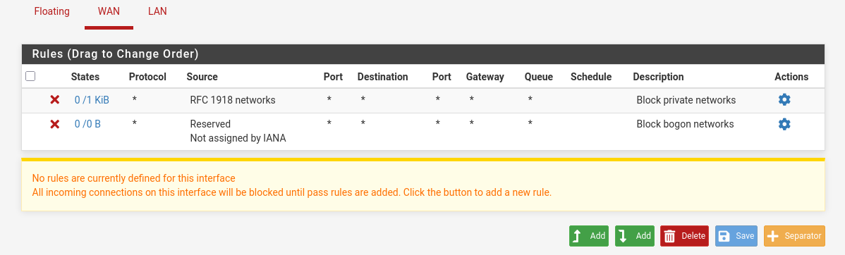
Because Pfsense is a statefull firewall, and in WAN interface there is no rules about block ICMP to LAN, so it can still get the ICMP reply when ping from WAN to LAN.

The next task is about blocking machines on host-only network to access website using HTTP protocol ( port 80 ). Let’s quick test the connection first before implementing the rule.
The machine on host-only can connect to the http website
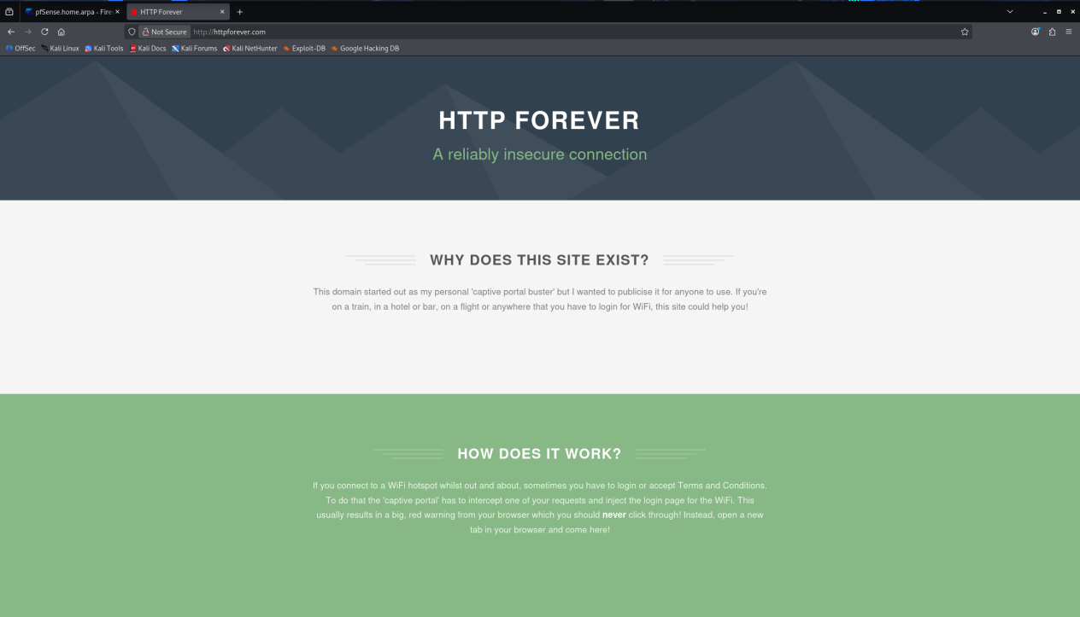
Now let’s setup new rule.

Block all traffic from LAN network to port 80 ( http protocol ).
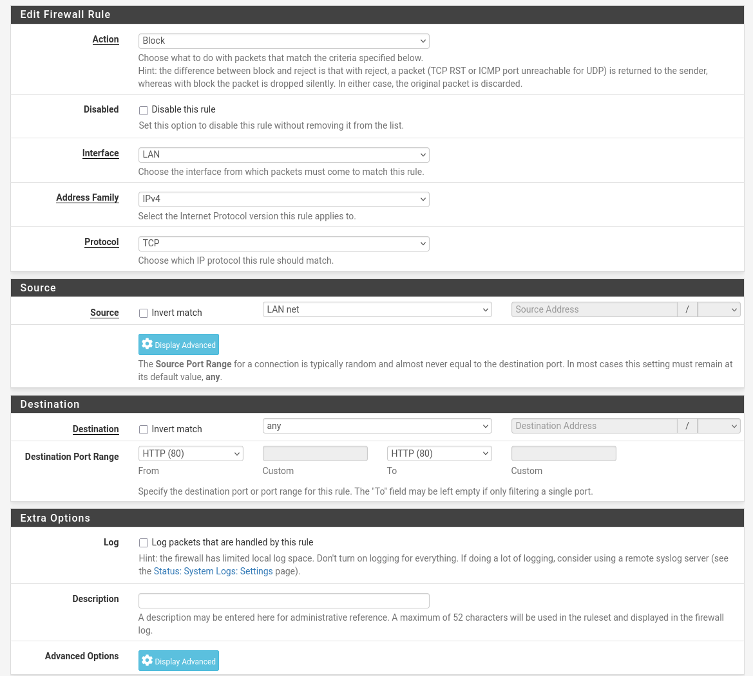
After that, I cannot access the website using http protocol.
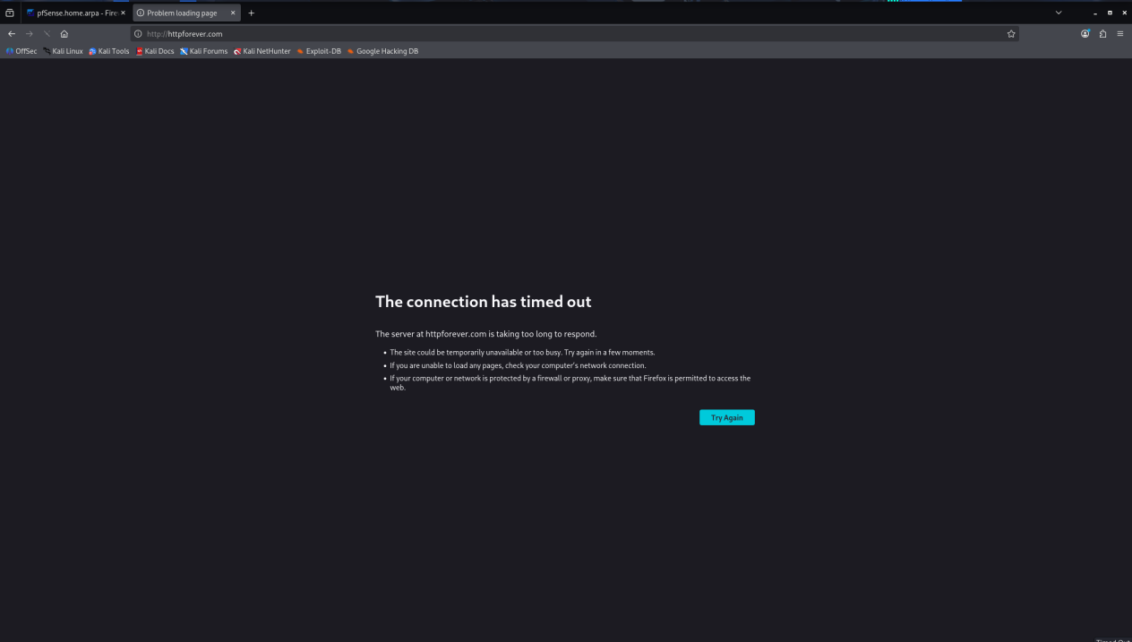
Also the curl could not work too.
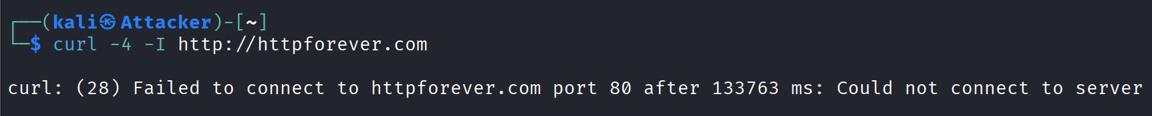
But I can still access the pfsense web UI cause of this default rule.

Task 3 ask us to block the telnet connection
Testing the telnet connection on hsot-only network to WAN network.
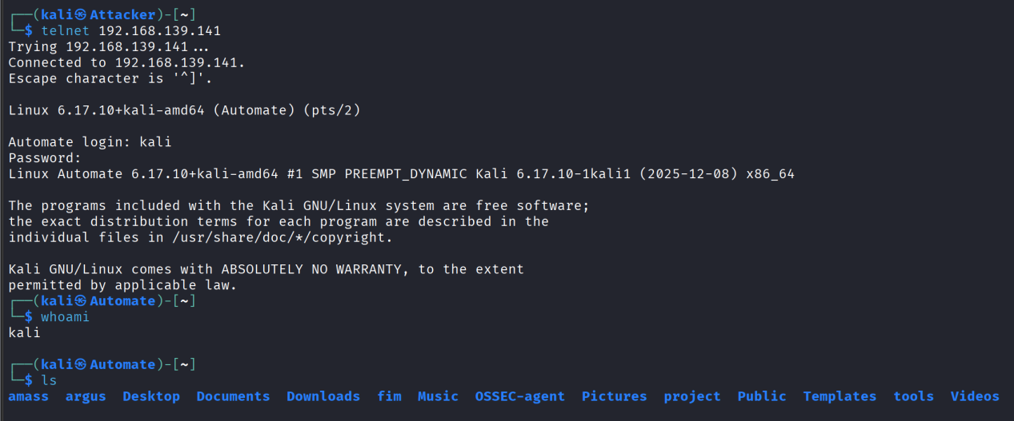
Creating a rule that block all telnet traffic.
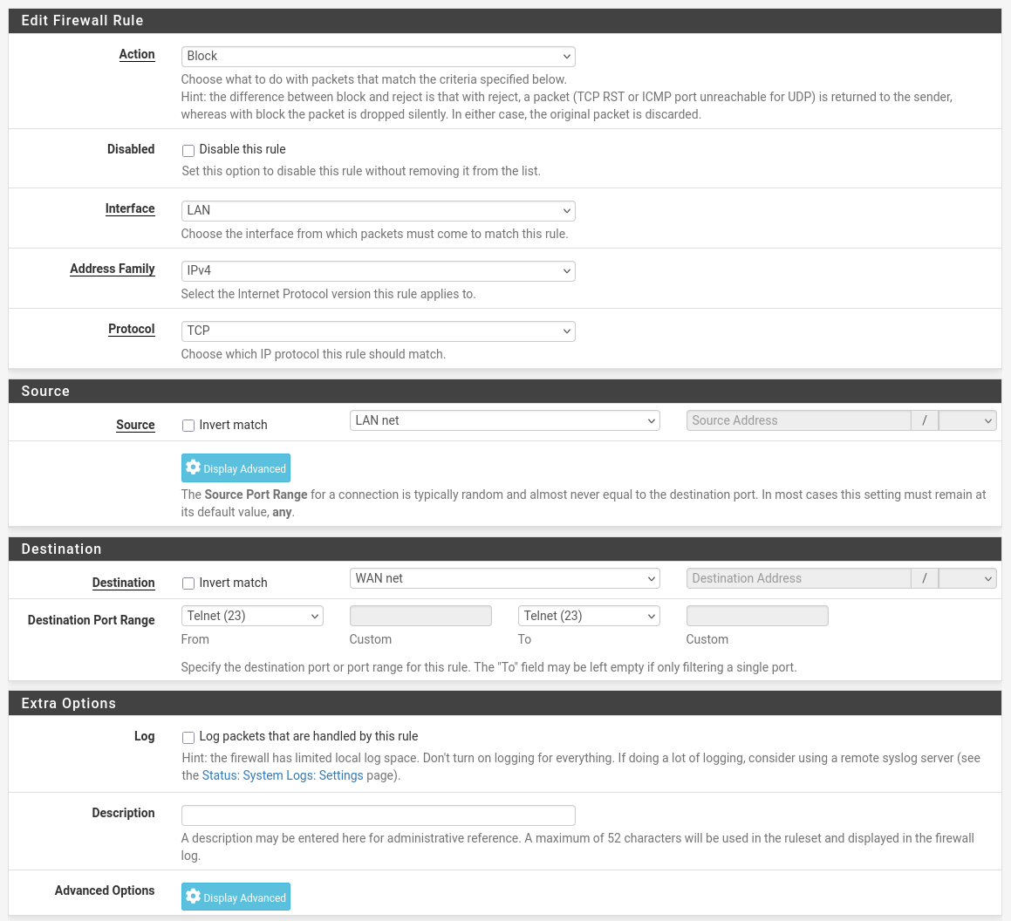
After that, it showed connection time out, the machine on host-only network can never reach out to machine outside with telnet.
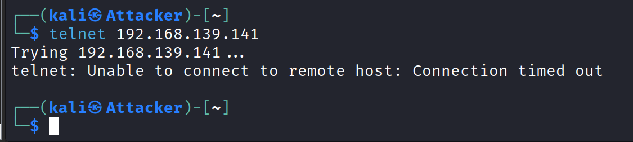

Now, let’s move to our last task that is not allow machines on the internal network to access www.facebook.com and youtube.com.
For now, the machine on host-only network can access youtube and facebook. Let’s implement some new rules.
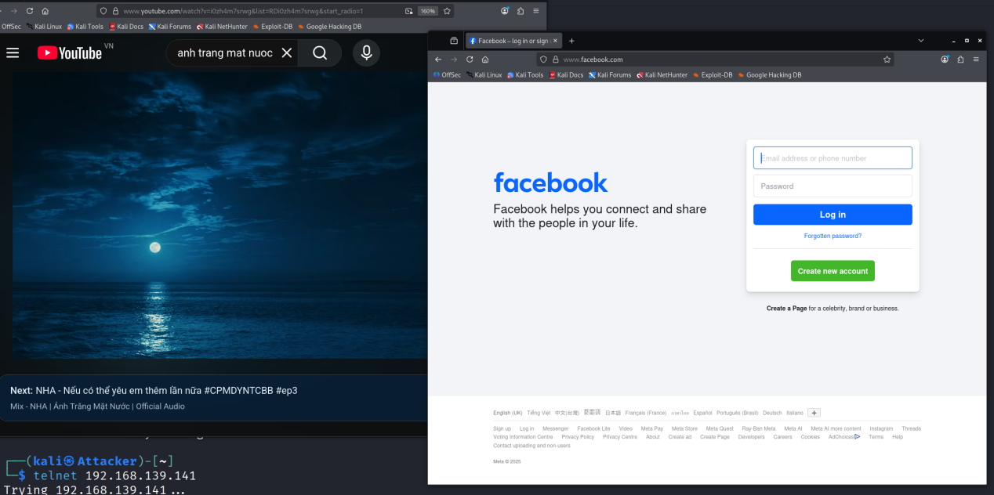
Blocking Facebook/YouTube IP addresses is incorrect because:
- IP addresses change constantly (CDN)
- IPv6
- SNI/HTTPS
- QUIC (UDP 443)
Blocking doesn't completely remove the address; it's easy to bypass.
That is why I config the DNS Resolver instead.
Host Override for facebook.com
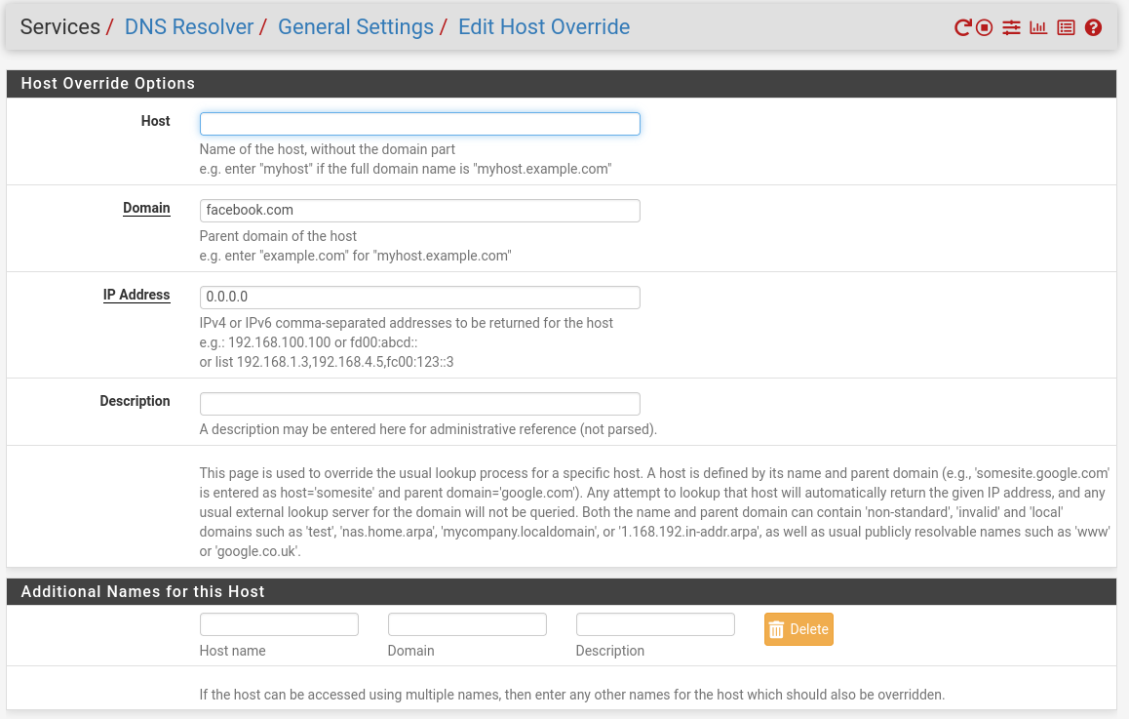

Host Override for youtube.com
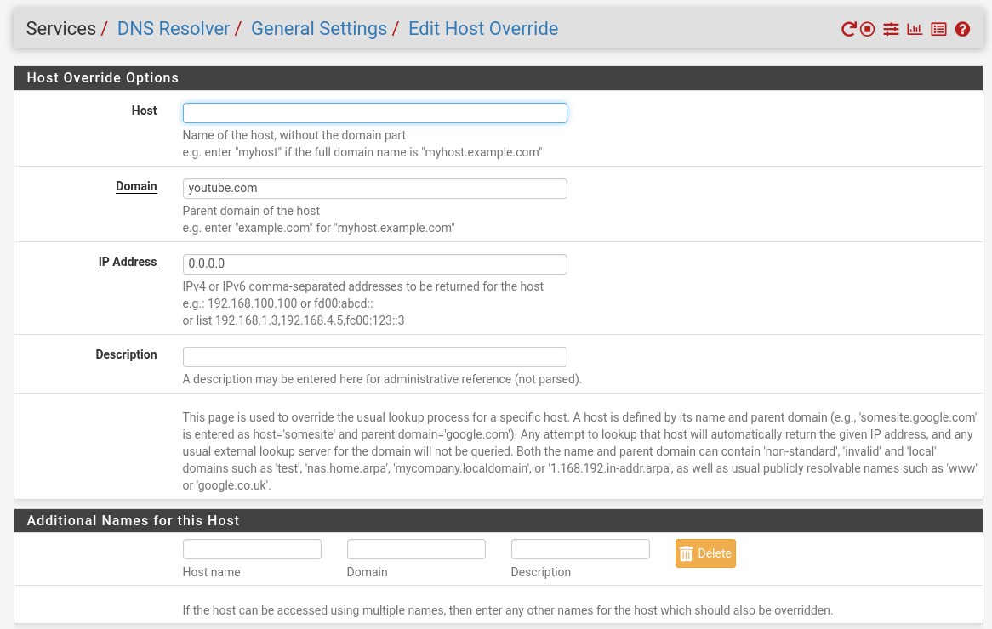
All host override configuration.
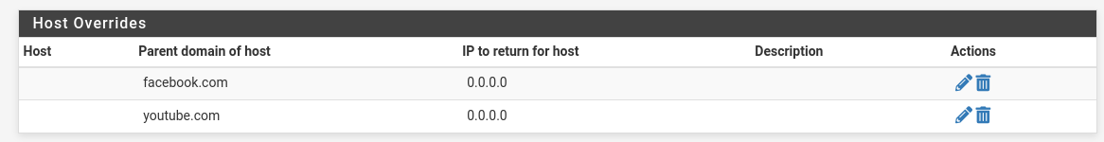
Now, user on host-only network cannot access youtube and facebook.
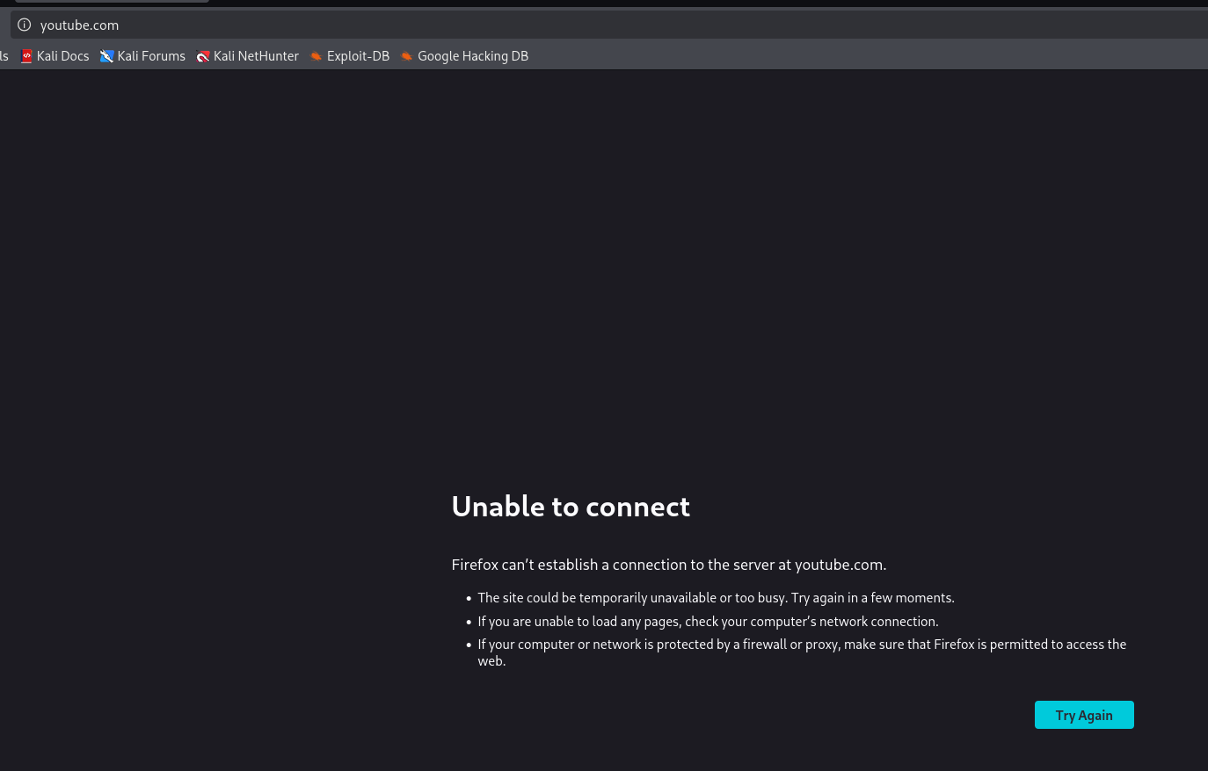
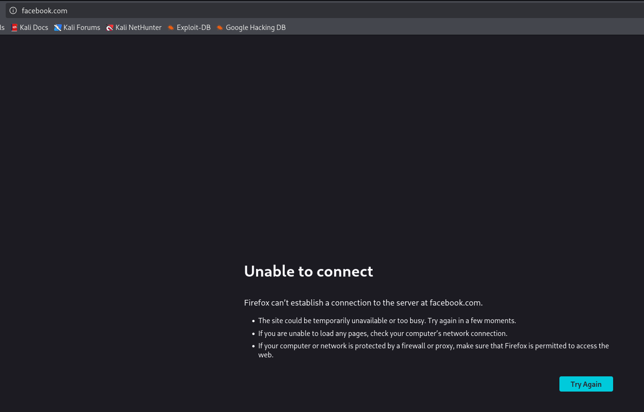
DNS-based blocking prevents access before the destination is resolved, while firewall-based blocking stops traffic after resolution but before the connection is established.

